Day 15 (05 July 2025)
112552596 - vsisukhw - Sukhwinder Singh

For tasks questions , refer
https://docs.google.com/document/d/1M_CVbeErw0eevs00h_z-EokJW4Is8ZGcJIvV9-qJPGQ/edit?tab=t.0

Task 1
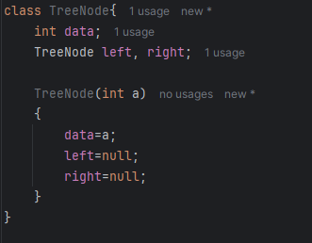
Task 2
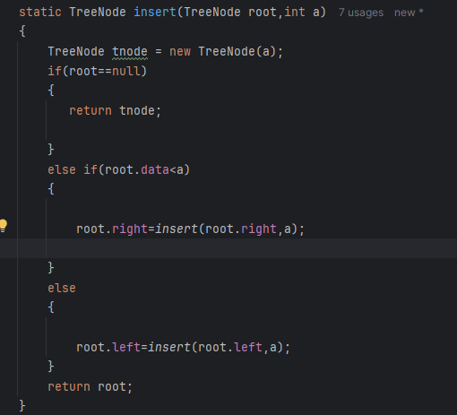
Task 3
In-order Traverse
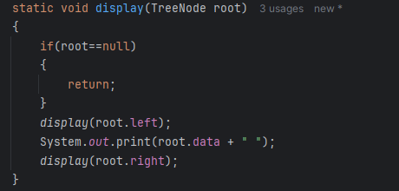
Task 4
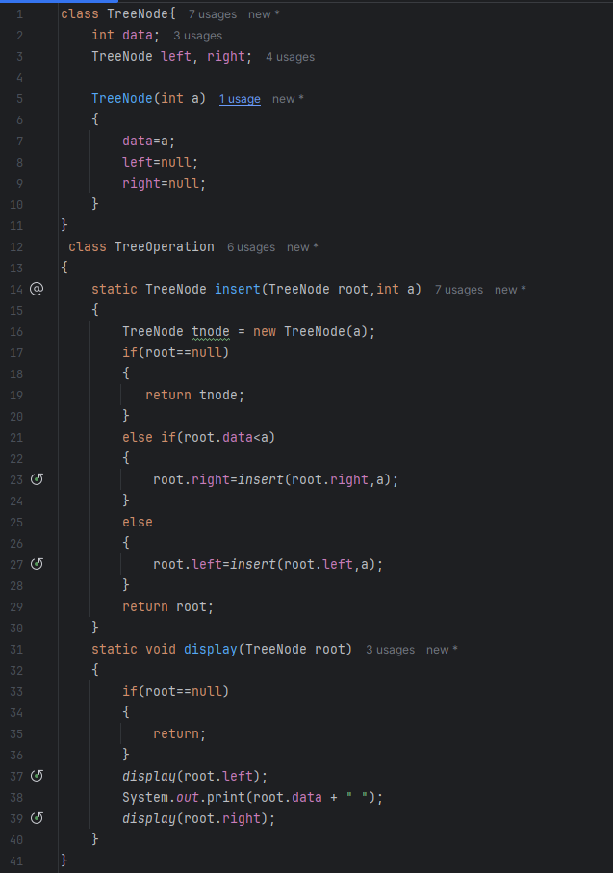
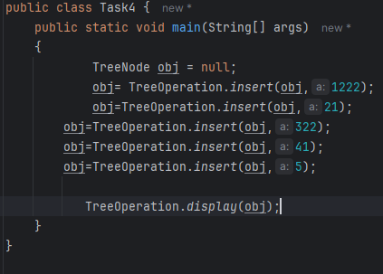
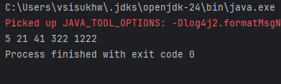
Task 5
Applications of Trees
1. Hierarchical Data Representation
- File systems (directories and files)
- Organization charts (CEO → managers → employees)
- Menu systems in software

2. Searching and Sorting
- Binary Search Trees (BST) for fast searching (O(log n) if balanced)
- AVL Trees, Red-Black Trees – Self-balancing BSTs used in libraries (like TreeMap, TreeSet in Java)
- B-Trees / B+ Trees – used in databases and file systems for efficient disk access

3. Routing and Network Applications
- Trie (Prefix Tree) – used in:
  - Autocomplete, spell-check
  - IP routing tables
- Spanning Trees – used in network protocols like Ethernet to avoid loops (e.g., STP – Spanning Tree Protocol)

4. Parsing and Expression Evaluation
- Expression Trees – represent and evaluate mathematical expressions
  - e.g., 3 + (4 * 5) → parse tree
- Used in compilers and interpreters

5. Artificial Intelligence / Game Trees
- Minimax trees used in game AI (e.g., Chess, Tic Tac Toe)
- Decision Trees used in:
  - Machine Learning
  - Rule-based systems

6. Database Indexing
- B-Trees and B+ Trees are used to index large databases
  - Efficient lookup, insert, delete for large-scale data

7. Compiler Design
- Abstract Syntax Tree (AST) represents source code structure
- Used for:
  - Syntax analysis
  - Code generation
  - Optimization

8. Memory Management
- Segment trees, binary indexed trees (Fenwick Trees) – used in:
  - Range queries (sum, min, max)
  - Memory allocation trees

9. File Compression (e.g., Huffman Coding)
- Huffman Tree used for:
  - Data compression (ZIP, JPEG)
  - Encodes characters using variable-length binary codes

10. Operating System
- Process scheduling trees
- Page tables (in multi-level paging, modeled as trees)
- I/O device trees

11. Used in Libraries and Languages
- Java's TreeMap, TreeSet → internally use Red-Black Trees
- Python's libraries like sortedcontainers (Tree-based sets/maps)

Task 6
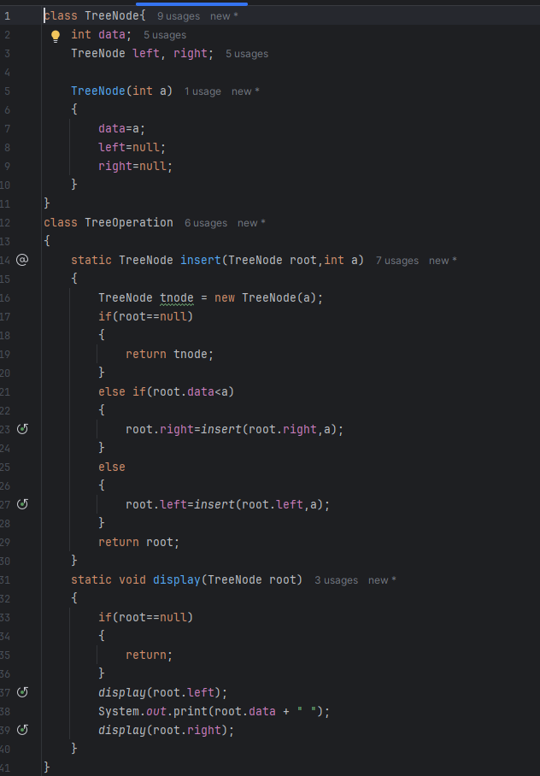
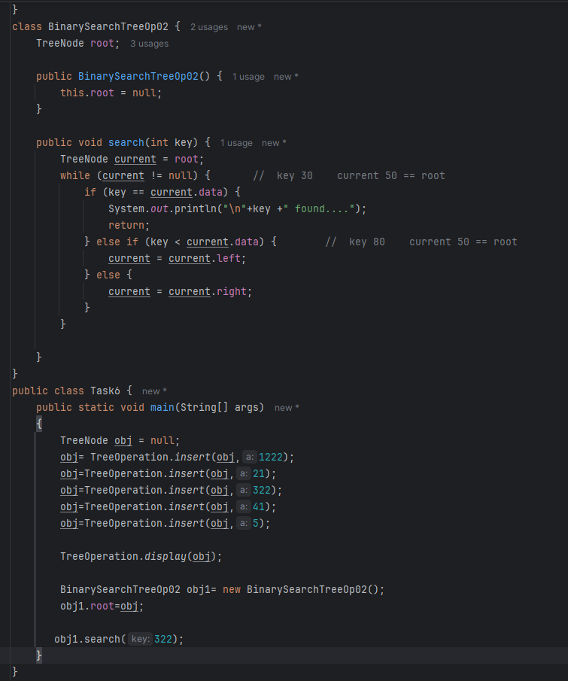
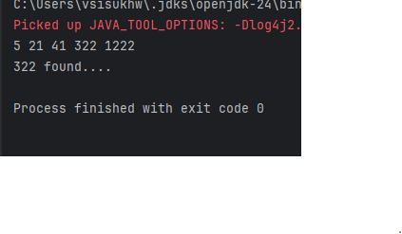
Task 7

Types of Binary Trees
- Full Binary Tree
Every node has 0 or 2 children — no single-child node allowed.
- Perfect Binary Tree
All internal nodes have 2 children, and all leaves are at the same level.
- Complete Binary Tree
All levels are filled, and the last level is filled left to right.
- Balanced Binary Tree
Height difference between left and right subtree is at most 1 for every node.
- Degenerate (Skewed) Tree
Each node has only one child — behaves like a linked list.
- Binary Search Tree (BST)
For every node: left child < root < right child — enables fast search.
Task 8

Applications of Graphs
- Social Networks
Users are nodes; friendships or follows are edges (e.g., Facebook, Instagram).
- Google Maps / GPS Navigation
Locations = nodes, roads = edges; used for shortest path & route planning.
- Internet / Network Routing
Routers = nodes, connections = edges; used in protocols like Dijkstra, OSPF.
- Web Page Ranking (Google Search)
Pages = nodes, hyperlinks = directed edges; PageRank algorithm uses graphs.
- Recommendation Systems
Users/items as nodes; edges show interactions (e.g., Netflix, Amazon suggestions).
- Airline Route Maps
Airports = nodes, direct flights = edges; find cheapest/fastest route.
- Job Scheduling / Task Planning (DAG)
Tasks = nodes, dependencies = edges; used in build systems, project management.
- Electrical Circuits
Components as nodes, wires as edges; used in circuit analysis.
- Biological Networks
Genes, proteins = nodes; interactions = edges (used in bioinformatics).
- Game AI (State Graphs)
States = nodes, moves = edges; used in chess, puzzles, decision-making.

Task 9

Types of Graphs :

Undirected Graph
Edges have no direction; if A is connected to B, B is also connected to A.
Directed Graph (Digraph)
Edges have direction; A → B does not imply B → A.
Weighted Graph
Each edge has a weight or cost; used in shortest path problems.
Unweighted Graph
Edges have no weights; all edges are treated equally.
Cyclic Graph
A path exists where you can return to the starting node (contains cycles).
Acyclic Graph
No cycles exist; used in task scheduling and dependency resolution.
Connected Graph
There’s a path between every pair of nodes (only in undirected graphs).
Disconnected Graph
Some nodes are isolated; not all nodes are reachable from each other.
Complete Graph
Every node is connected to every other node.
Sparse Graph
Has relatively few edges compared to the number of nodes.
Dense Graph
Has many edges, close to the maximum number possible.
Tree (a special graph)
Connected acyclic graph with n nodes and n−1 edges.
DAG (Directed Acyclic Graph)
A directed graph with no cycles; used in scheduling, compiler design.
Task 10
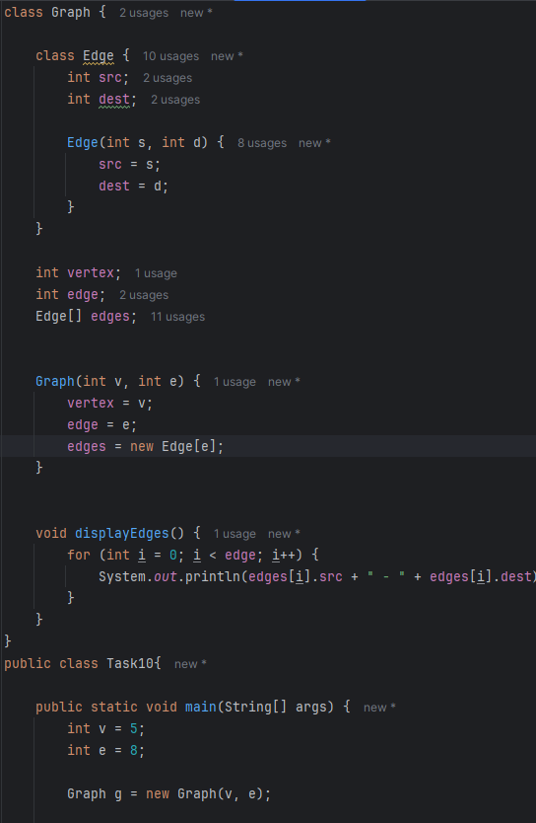
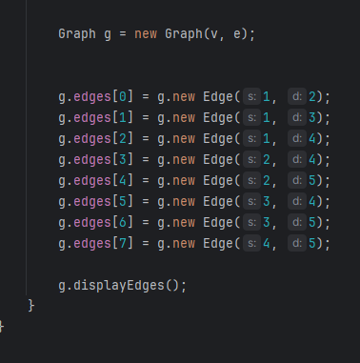
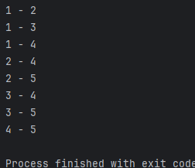
Task 11

